INTRODUCTION TO CLOUD COMPUTING Lab
Task 09 (B) (Implement Azure Container Instances)

Name: Arshia M Ali
ID: 2280140
Section: BSSE 7-B

Task 1: Deploy an Azure Container Instance using a Docker image.
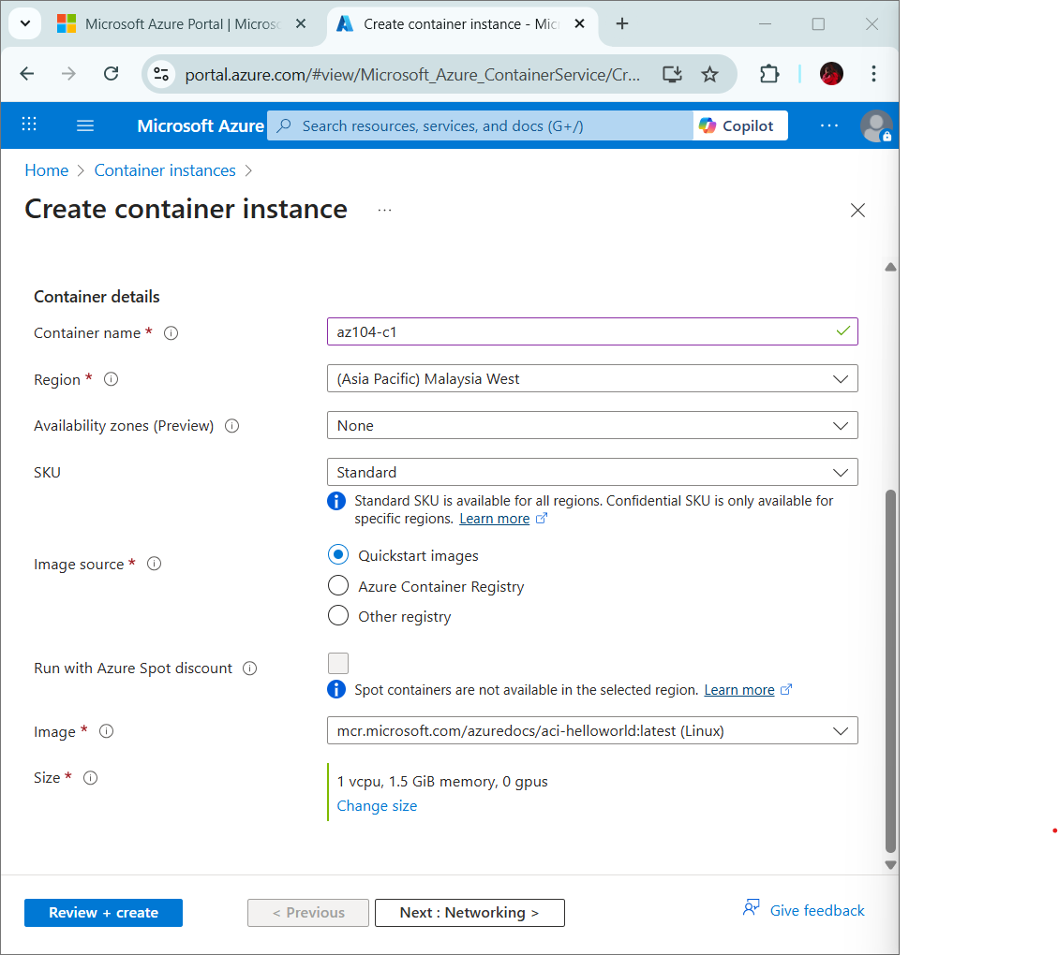
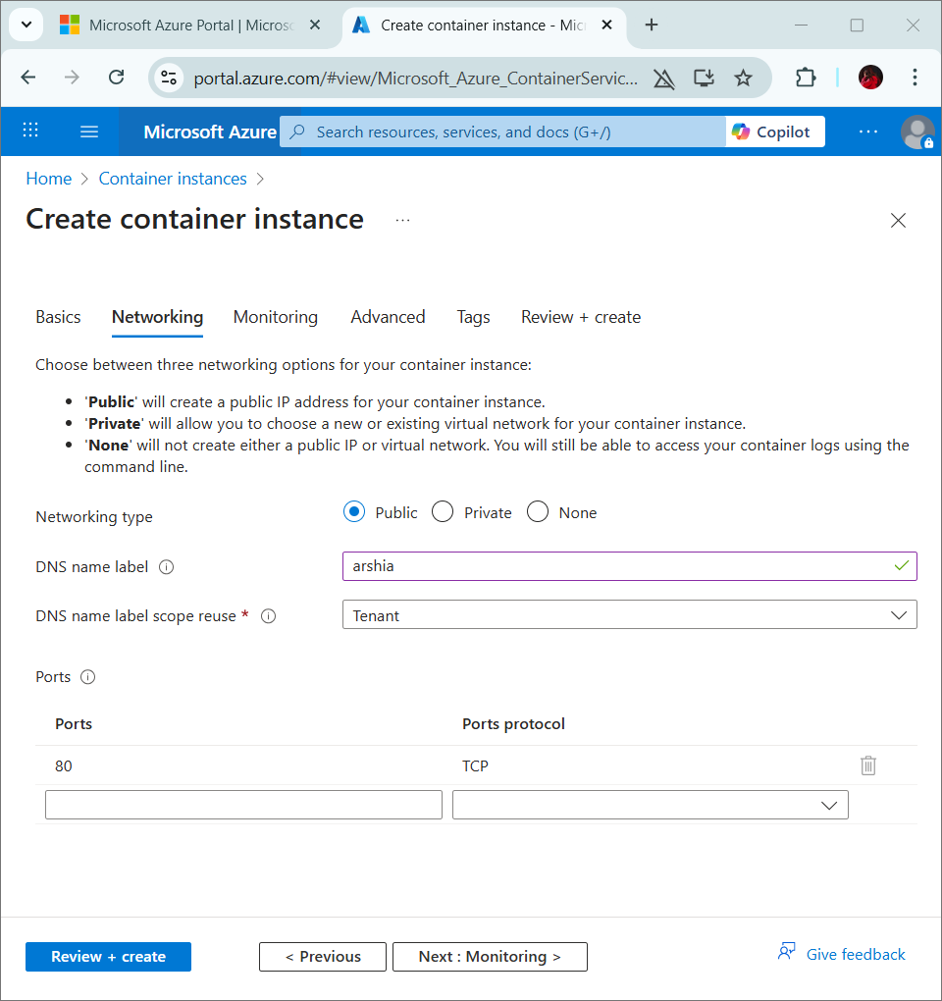
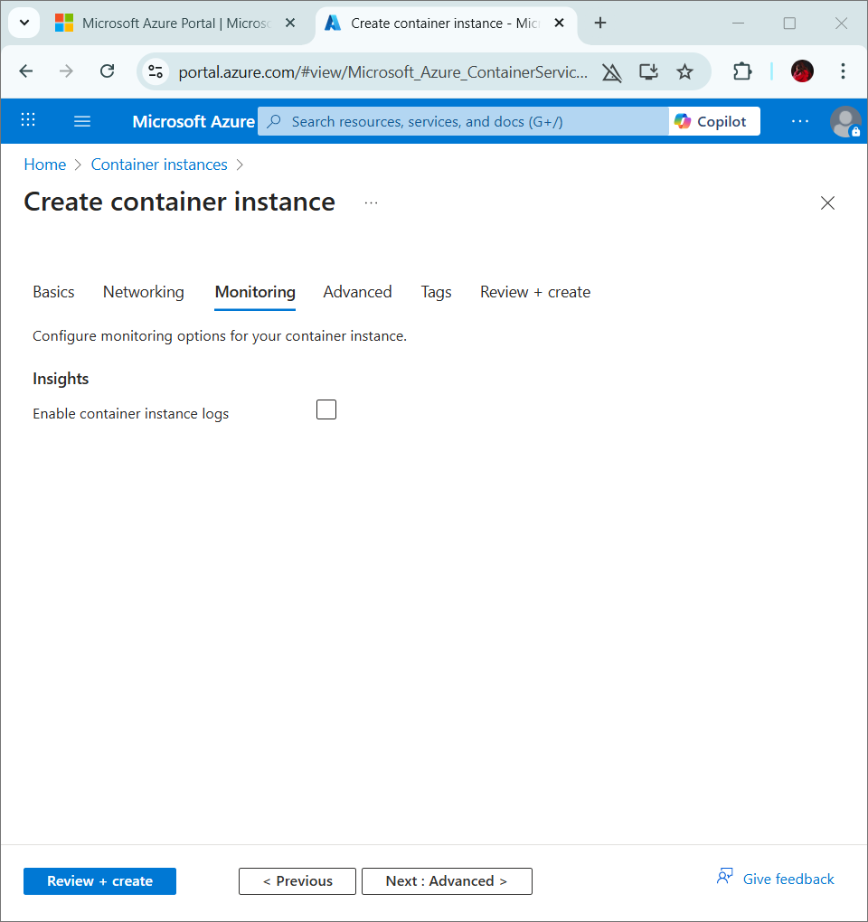
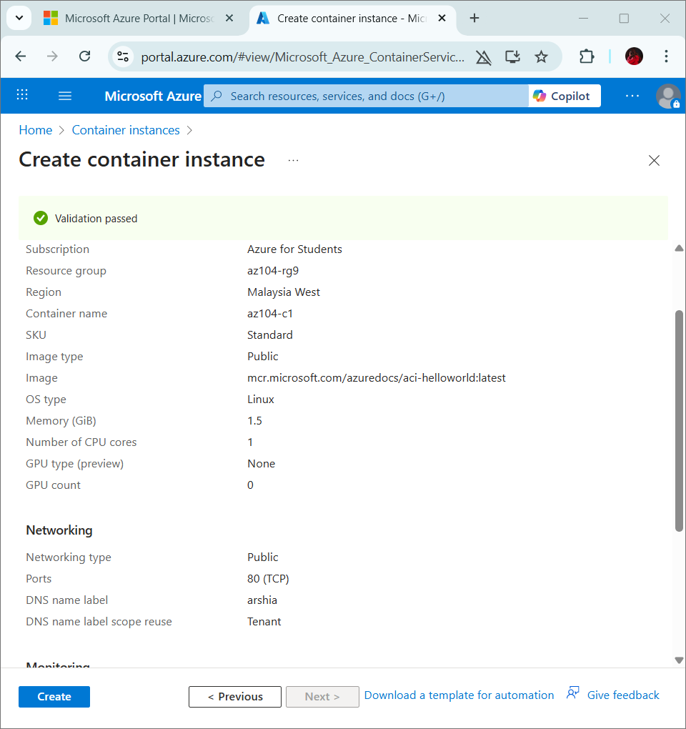
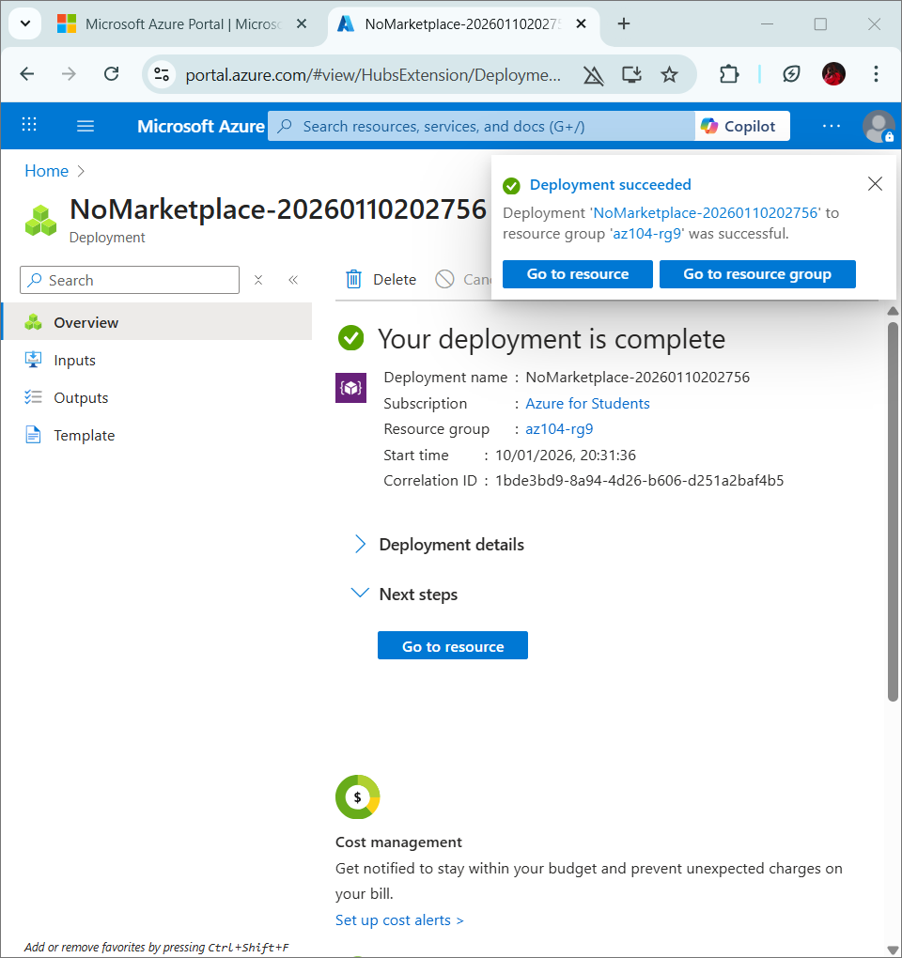

Task 2: Test and verify deployment of an Azure Container Instance.
